Title: The Influence of Predicted Effort and Time Constraint on Decisions between Actions

Flàvia Ferrús¹, David Farré-Gil¹ and Ignasi Cos^{1,2,3}

¹Facultat de Mathemàtiques i Informàtica, Universitat de Barcelona, Gran Via de les Corts Catalanes 585, 08007 Barcelona, Catalonia, Spain

²Institut de Matemàtiques de la Universitat de Barcelona (IMUB), Gran Via de les Corts Catalanes 585, 08007 Barcelona, Catalonia, Spain.

³Serra-Húnter Fellow Programme, 08010 Barcelona, Catalonia, Spain

Corresponding Author: Ignasi Cos; ignasi.cos@ub.edu

Abstract

Introduction
The staggering speed and accuracy of table tennis players may suggest that a brisk preparation of precision movements is compatible with an accurate and energetic execution. Indeed, to win a competitive match often depends on pushing it to your limit to balance precision, accuracy and speed (Trommershäuser et al., 2008; Keramati et al., 2011; Landy et al., 2012; Peternel et al., 2017), to ultimately return the ball inbounds while respecting game constraints. This means short preparation intervals to generate and execute fast and precise executions. Related to this, significant contributions to our understanding of the principles encompassing distance, arrival dispersion and movement time in motor control suggest that the control of precision abides by speed-accuracy trade-offs (Fitts, 1954; Trommershäuser et al., 2006, 2008; Berret et al., 2021). However, the manner in which these principles degrade under serious time pressure to prepare the movement and sustained effort execution conditions remain unclear.

The operation of selecting movement parameters when not enough time for a full consideration is given remains a matter of considerable debate (Young et al., 2009; Bogacz et al., 2010; Salinas et al., 2014). In particular, all evidence suggests that decisions between movements abide by considerations of predicted benefits and costs that create a cognitive high ground for motor control and decision-making (Stevens et al., 2005; Shadmehr et al., 2010; Krakauer and Mazzoni, 2011; Rigoux and Guigon, 2012, 2012; Norbury et al., 2016), that interacts with well-known speed-accuracy trade-off adaptive strategies to the precision of specific movements. While this is well captured by stochastic models of optimal feedback motor control (Todorov, 2004; Guigon et al., 2008; Berret et al., 2021), the manner in which specific contextual or specific task constraints influence the necessary process of preparation and assessment are not formalized.

Previous evidence showed that the subjective considerations of effort (Morel et al., 2017; Summerside and Ahmed, 2021) are integrated with predictions of more rewarding states (Krakauer and Mazzoni, 2011; Norbury et al., 2016), in a general process of option evaluation to make convenient decisions between movements (Stevens et al., 2005; Shadmehr et al., 2010; Rigoux and Guigon, 2012). In other words, if the principles of motor control and decision-making are consistent with the optimization of utilities associated to different options (Kahneman and Tversky, 1979; Shadmehr et al., 2010; Rigoux and Guigon, 2012). However, what happens when movements cannot be properly prepared in a context that demands accuracy and sustained energy expenditure?

On the one hand, the speed with which biomechanical costs (less than 150ms) can be predicted, to still favour the selection of specific moving directions (Cos et al., 2011, 2014) supports the hypothesis that cognitive cost-benefit considerations could also be fast. However, reasonable doubt remains as to the generality of these optimization principles when it is not given the conditions to be optimal. Do we compromise with a suboptimal solution or do we follow another process to reach the optimum, e.g., retrieving previous solutions? Evidence shows that control strategies vary as a function of the task constraints and demands, e.g., the level of control of mechanical impedance depends on the nature of the movement and required accuracy (Selen et al. 2005, 2006) and on additional task constraints (Gomi and Osu 1998; Trommershäuser et al. 2003). Is it the same with sustained effort and constrained preparation time?

Here we aim at the characterization of the influence of time pressure on movements preparation and of sustained effort levels of effort on decisions between reaching movements. To this end, we developed an experimental setup in which human participants performed free choices between movements that differed in path distance and biomechanical costs (Cos et al., 2011). There within, we varied the experimental conditions to reduce preparation time and to vary the level of sustained effort to be performed when making each movement. Furthermore, we developed a stochastic computational model of motor control and decision-making aimed at reproducing movements and decisions between them while capturing the participant’s sensitivity to effort and time, and their dispersion. We then used this computational context to study how our experimental factors altered the progress of each participant. Our results show that increasing sustained effort significantly degraded movement accuracy and triggers a chain of principled adaptive mechanisms that were specific of each participant. By contrast, the constrained preparation time did not significantly alter neither movement accuracy nor the specifics of movement, consistently with the hypothesis of rapid cost-benefit considerations.

Materials and Methods
Characterization of Effort and Preparation Time
We designed our experiment to quantify the influence of physical effort and preparatory time on decisions between action movements, and on the movements themselves. To this end, we adapted a previous experimental setup, in which subjects were presented with action choices implying the opposite biomechanical cost, each associated with specific movement directions (Cos et al., 2021, 2011). In brief, participants had to select one of two reaching movements presented at each trial, and perform the movement of their choosing with their dominant arm, while respecting two constraints. First, each reaching movement had to be performed while holding a dynamometer in their hand and exerting one of three levels of force (as to modulate physical effort). These three levels of physical effort were expressed as percentages of an average Maximum Voluntary Force of 350N: 1. Baseline or E0 Level, 0% MVF; 2. Weak Force (WF) or E1, 6% MVF; 3. Strong Force (SF), 12% MVF. Second, participants were given a fixed interval (response time) to report their choice; either 1000ms (Long Time condition --- LT; condition) or 300ms (Short Time --- ST; condition).

Participants
Twelve right-handed participants (8 males, 4 females; Mage = 24.0y, SD = 5.0), participated in this study. All had normal or corrected-to-normal vision and hearing, and did not suffer from any known neurological disorder. Informed consent was obtained following the guidelines established by the local ethics committee and all participants received monetary compensation (10€/h) for their participation, regardless of completion. The ethics protocol for this study was approved by the Clinical Research Ethics Committee (CEIC-Parc Salut MAR) of the Hospital del Mar of Barcelona, Ref. #2021/6085/I. All methods were carried out in accordance with relevant guidelines and regulations.

Experimental Setup
Participants were seated in a comfortable chair, in front of a table with an Acer G245HQ computer screen (1920x1080) on it. This monitor was connected to an Intel i7 (3.20GHz, 64-bit OS, 16 GB RAM) personal computer. The screen was used to show the geometrical arrangements and stimuli at each trial. Simultaneously, we used an Optitrak 3D motion tracking system (Optitrak, Inc), to track the position of a spherical marker glued to the top of a hand dynamometer (Vernier, Inc). This dynamometer was held by the participant in his/her right hand while performing the trials. Participants executed their movements, always maintaining the dynamometer vertical and in contact (although not exerting pressure) with the table horizontal surface. The table was placed at a comfortable height for the participant. A chinrest was also used to stabilize posture at a fixed distance from the screen, and to minimize head movements. An Eyetribe (Eyetribe, Inc; DK) oculometer was placed under the screen to track the participants’ gaze and pupil size. The task flow control was performed with a custom-built script, programmed with OpenFrameworks v.1.0.2 and custom-built MATLAB scripts (The Mathworks, Natick, MA), licensed to the Universitat de Barcelona. Data from each session was transferred to a MySQL database (Oracle, CA), for further analysis using custom-designed MATLAB scripts (Mathworks, Natick, MA).

FIG 1

The participant was instructed to place his/her chin on the chinrest and hold the dynamometer in his/her right hand while maintaining its orientation always vertical, and to never bend the wrist. The experimenter visually monitored the experiment to ensure that the subject complied with these requirements.

Experimental Task
The task consisted of 1,200 trials of twenty-four possible types. Within each trial, each potential reaching path was defined by the origin cue (cyan circle, radius 1cm), a via-point (red circle, radius 1cm), separated from the origin by 3cm, and one of two wide rectangular targets (width: 10cm; depth: 1cm), each separated from the origin by ~10cm. We considered 3 Levels of Effort (E0, E1, E2) x 2 Preparatory Times (ST/LT) x 4 Geometrical Arrangements (Top-Left: TL, Top-Right: TR; Bottom-Left: BL, Bottom-Right: BR) --- FIG 1B. We defined a trial-type notation, based on Effort x Preparatory Time to characterize the influence of both main factors, namely trials could be of the following types: E0-LT, E0-ST; E1-LT, E1-ST; E2-LT, E2-ST. For the participants not to be able to anticipate trial types, we prepared a randomly generated sequence of trials, distributed into 12 blocks. The order of the blocks was counterbalanced across participants. Each block contained four repetitions of the 24 trial types each. The remaining 4 trials per block were single-target trials, in which a single movement option was presented, one from each of the four geometrical arrangements. These trials were intended to force the participant to experience all movements, and to encourage informed choices when presented with both options. Single target trials were of type LT-E0.

The timeline of each trial was as follows: it starts with a blank screen, followed by the presentation of an origin cue (green dot) at the centre of the screen 500ms later. This signalled the participant to slide her/his right hand on the table (holding the dynamometer vertically) for the grey cross on the screen, synchronized with the position of the marker on the dynamometer, entered the origin cue. 200-300ms later, a via point (pale blue dot) and the targets (5x1cm rectangles) were shown in their apposite locations, defining the two potential reaching paths from the origin cue. After 500ms interval, the origin cue disappeared, signalling the GO. At that point, the participant was required to report his/her choice by initiating a movement within a time window of 400 or 1000ms, while pressing on the dynamometer with a force larger than 0%, 5%, 20% of the MVF, depending on the type of trial. The participant was required to move towards one of the two rectangle targets (whichever they chose), always passing through the blue via-point in-between. Once the endpoint entered a rectangle target, the target would turn green. 500ms later, all cues would disappear, and the subject would be presented with a precision score by means of a horizontal score bar in the centre of the screen. The screen would go blank again 500ms later, indicating the end of the trial.

The instruction to the participant was to choose and perform a reaching movement from a circular origin cue (diameter: 1.5cm) to one of both rectangular targets (width: 10cm; depth: 1cm), placed 15 cm apart (FIG 1), right and left, and aligned with directions of maximal/minimal biomechanical cost (Cos et al., 2011) for arm planar reaching movements. We explained to the participant that she/he had a free choice to make, and that reward was dependent upon the arrival position along the long rectangle side. They were also informed that the goal was to attain maximum precision/reward scores, and that these depended on their aiming accuracy. The reward was calculated on the basis of how central the trajectory entered the rectangle (one if it hit the centre, zero if it missed, linearly decreasing in between), and the time it took them to do so since the trial started (GO signal) --- see FIG 1B.

* Geometric arrangements
******************************************************************************************

For non-baseline trials (efforE1, E2), the participants were instructed to apply force on the dynamometer over a specific threshold from the moment the origin went white until the rectangle turns green. Whenever they failed to produce enough force visual feedback disappeared, the cursor would disappear briefly and reappeared whenever the force crossed over the threshold again. This serviced for the participant to help them measure their force.
For us to study the trade-off between time and accuracy, the time the subject had to perform each trial was constrained to a maximum of 5s. Depending on the speed at which the subject reached the green dot when it appears, they had a maximum of 2s to go from the origin to their target of choice. Furthermore, they also had a strictly boundary time to leave the origin: 350ms (ST Trials), and 700ms (LT Trials). If they exited the origin later than MRT, the trial was considered a failure and the screen went blank, until the next trial began.
Furthermore, as to study broaden our conclusion about the influence of effort and time preparatory constraints on the choice of movement across the sagittal and transverse planes, we included four potential locations for the via-point and targets to be presented. These correspond with the quadrant of the screen where the via-point and targets were presented: Top Right (TR), Top Left (TL), Bottom Left (BL) and Bottom Right (BR), see Figure 1.2.

Behavioural Analyses
Each end-point trajectory was first low-pass filtered at 10Hz. We then identified and quantified the following kinematic markers for each individual trajectory: Peak Velocity (PV), Time-to-Peak Velocity (TTPV), Movement Time (MT), in addition to arrival Error (E). These metrics were then z-scored for each participant for statistical analyses, and performed a Greenhouse-Geisser correction for non-sphericity.
We then fitted a generalized linear model (GLM) on a single subject basis for each of these metrics. The GLM included the following variables: Energy (E; 0-Baseline, 1-WF, 2-SF), Reaction Time (RT; 0-Long Time, 1-Short Time), Biomechanical Cost (BC; 0-Low Cost, 1-High Cost) and their interactions, as defined by EQ 1.
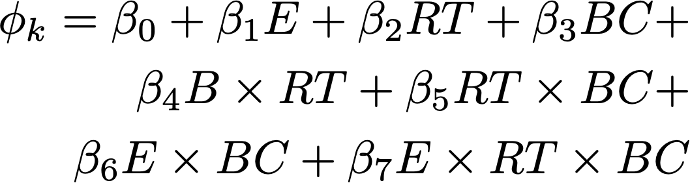 (1)
For each metric, we identified the regression coefficients β that significantly differ from 0 by running a Mann-Whitney-Wilcoxon (rank sum) test between the distribution of β pooled over all subjects and a null distribution. We set the threshold for group significance at p<0.05 with the Mann-Whitney-Wilcoxon (rank sum) test to compare the distribution of regression coefficients estimated from the data and the corresponding null/surrogate distribution. The null distribution was built by shuffling the regressed values φ^{k} across trials within each subject, then pooling the surrogate coefficients of each type across all subjects together. Note that the z-scoring applied to the kinematic markers allows for the alignment of the distributions across the different subjects.

Oculometry Analyses

As for the movement markers, we recorded and z-scored pupil diameter and regressed this metric with the same GLM used to test behaviour. We calculated the GLM β−coefficients per subject at each 30ms during two intervals, centred around the tSO and at the tGO events (FIG 4C-D). We determined group significance for each variable by running a t-test across the β−regression coefficients obtained across subjects (FIG 4A). Again, the threshold for statistical significance was set at p<0.05 (without correction for multiple comparison, considering each time step to be independent).

Computational Model
With the purpose of studying the participant’s adaptation to costly contexts, we developed a simplified motor control model of planar arm movements by considering a point of mass, which varied proportionally to the arm’s inertia along the moving direction. The inertia along the moving direction may be derived from the following tensor
,

where 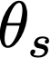 and 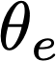 are the shoulder and elbow angles, and l_{s} and l_{e} are the arm segment lengths. The remaining parameters are averaged arm segment masses and mass-center distances, which have the following average values: m_{s} 1.76 kg, m_{e} 1.65 kg, c_{s} 0.475, and c_{e} 0.42 (Sabes and Jordan, 1997).

The dynamics of the moving dot are defined by the following set of stochastic differential equations:

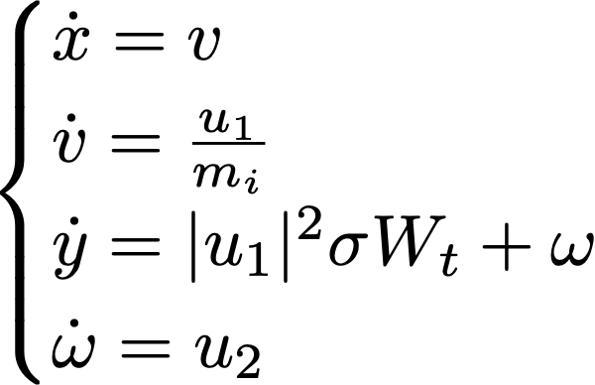

where x and y are the planar Cartesian coordinates and 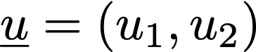 is the force exerted along each axis.  and  are the velocity components along the x, y axes, respectively, and  is the motor noise. The solution to this system of equations is the u(t) function that optimizes the following expression of utility (J):

The first term of the utility represents the benefit of the movement, and depends on the accuracy at target arrival. The closer is the trajectory to the centre of the target, the larger will be its value. The second term represents the costs. This costs accumulates (by integrating) the force exerted by the participant, pondered by the biomechanical cost , and an exponential temporal discount (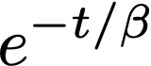). This latter term exerts both an influence on the total reward the participant receives. The benefit and cost terms are bound together by the constant , which represents the sensibility to the effort (or cost) with respect to the benefit term.

To solve the problem, we assume the following boundary conditions:

If T is the movement time, we arrive at the target according to the following constraints:

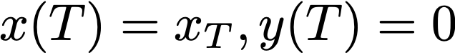

According to these, we may formulate the Hamiltonian of our system, as given by:

where

We then may find the resulting optimal control functions, defined as follows:

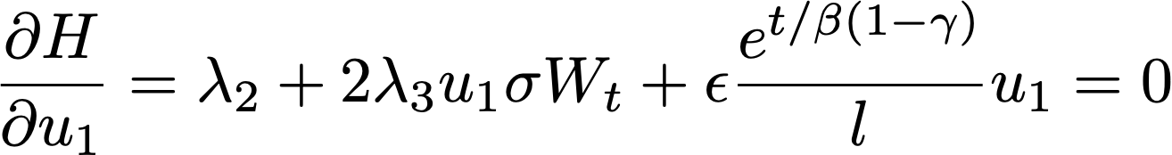

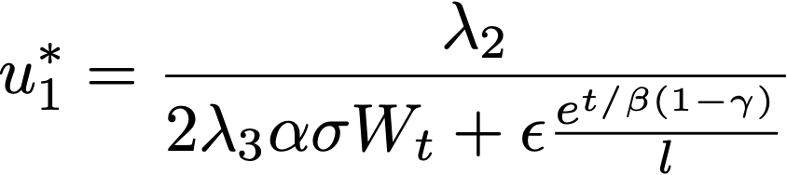

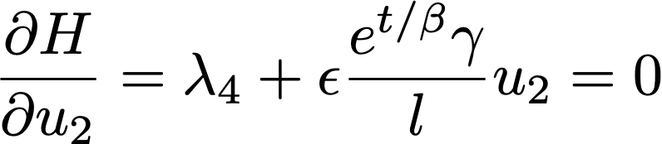

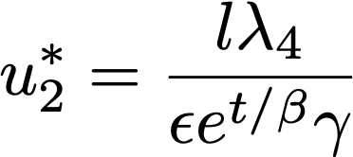

and study then the derivatives of the Lagrange multipliers with respect to the variables of movement:

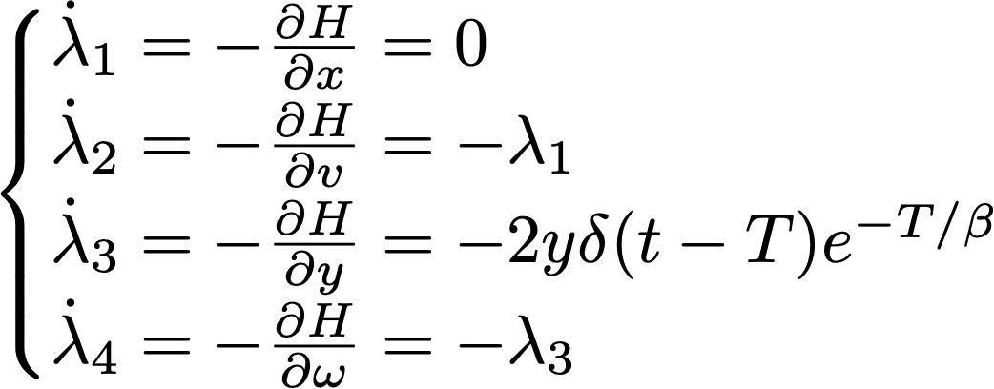

These four differential equations, combined with the control functions (u) and the original dynamics’ equations define a complete dynamical system, which we may now solve by numerical methods. Because of the nature of the problem, in which we need to account for constraints at the end of the movement, the system cannot be solved by integration methods alone. To bypass this problem, we applied the Shooting Method (Morrison et al., 1962), which aims at finding the initial conditions that would yield the terminal constraints imposed by our problem (in our case the initial conditions of u₁ and u₂). In other words, using appropriate minimization techniques, we “shoot” trajectories from randomly selected initial conditions until finding the initial conditions that yield trajectories that ultimately satisfy x(T)=x_{T}.

Fitting Free Model Parameters
The model has four free parameters: 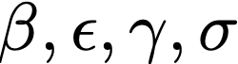. Because the model is stochastic, we tried to fit statistical distributions, rather than scalar values. In this work, we use a Frequentist approach to obtain the most likely set of parameters. To this end, we consider the parameters to assume a normal distribution, thus reducing the problem to fitting their mean and standard deviation.

Furthermore, as part of the fitting process, we first focused on the noise free case () as to obtain a first order approximation of the desired solution. In doing so, we are in fact searching for the set of parameters 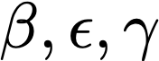 such that the output trajectory were the closest to the average --- assuming that the noise is symmetric towards either side of the trajectory. However, finding the average trajectories to guide our fit would mean several complications due to the nature of the data. First, the trajectories are time series of variable length, some somewhat delayed. However, we can still fit a parametric estimate of the trajectory, rather than the entire time series. To this end, it is critical to properly select the appropriate proxies for our trajectories; namely the movement time, from leaving the origin until reaching the target, and the peak velocity, as a proxy of movement intensity. With these, we can obtain an average MTs, and an average Peak Velocities (PV), and subsequently search for the vector () which produces estimators (MT2, PV2) closest to (MT, PV). Our metric of error computes the difference between both estimators equally. In summary, the optimal parameters obtained result from a minimization of the MSE (Mean Squared Error) over the estimated MT and PV with respect to the experimental average of each participant. Once these parameters are fit, we fixed them, and sought for the optimal , such that it can be used to model the error distribution at target arrival.

As for the former case of finding the optimal  parameters, we used a proxy of the error distribution at target arrival. It is worth noting that the relevant estimator in the case of  is remarkably different than the ones used previously. Even though MT, PV are key features of the type of movement, their dispersion does not inform much of the nuances of the distribution. On the other hand, the error when reaching the target, i.e. horizontal translation with respect to the centre of the target side (ranging from 0 to 1) is more descriptive of the variability of the movement. It is this error, after all, that we want to study in the speed-accuracy trade-off. Because of this, we use this estimator, which we accumulate in xT_samples. Because of the need of characterizing a distribution, we cannot simply simulate once to then quantify the distance between the estimators. We are looking for a sigma such that the distribution of errors it produces, xT2_samples is the most similar to the distribution of errors in the original data xT_samples. To obtain xT2_samples we need to simulate several times (we worked with 50), and store all the errors from these simulations. Once this was done, we could then use the Kolmogorov Smirnov Test loss function, a statistical test that determines the difference between two given distributions example to assess differences. The lower the result of the KS Test, the better our  was fitting the variance calculated from our original data.

Results
To test our hypotheses that sustained effort and limited preparatory time degrade the principles regulating adaptive mechanisms of motor control, we performed an experiment in which eleven participants performed a decision-making task between precision reaching movements. At each trial, the participant had to freely choose a target, and to report it with a right arm planar reaching movement. Regardless of the movement selected, the participant was instructed to be accurate upon target arrival (see METHODS). We varied two factors in the experiment; the duration of the movement preparatory time (Early < 400ms or Late < 1000ms), the intensity of the sustained force to be applied on the hand dynamometer while reporting the movement (Baseline 0% - MVF; Weak 5%MVF; Strong 12%MVF) --- see METHODS. The two potential path-trajectories started from an origin cue and passed through a common via-point, to end along the long side of one of two rectangular targets. There were four possible geometrical arrangements (Bottom-Right --- BR; Top-left ---TL; Bottom-Left --- BL; Top-Right ---TR), in which both movements implied the opposite biomechanical cost (Cos et al., 2011). Although the task did not use any explicit reward, the participants were informed of their performance at each target arrival (FIG 1B).

The Influence of Physical Effort and Preparatory Time on End-Point Accuracy
A set of typical trajectories for baseline trials is shown in FIG 2B (participant #2) and FIG 2C (participant #10). We predicted that, increased of motor noise caused by sustained force exertion on the dynamometer (Harris and Wolpert, 1998), the error upon arrival should positively co-vary with sustained effort. Furthermore, if both movements are carefully planned prior to movement onset, reducing the allowed preparatory time should yield increased variability and, consequently, end-point accuracy. To assess this, we recorded the planar trajectories performed by each participant to report his/her choices, as well as their pupil diameter, throughout the entire trial (see METHODS). In addition to the arrival error (E), we calculated movement times (MT) and peak velocities (PV) as proxies to characterize speed and movement intensity. We then assessed the influence of the two main experimental factors: Effort (E) exerted on the dynamometer (none, weak force, strong force), the Preparatory Time duration (PT; Short/Long), as well as the Biomechanical Cost (BC) of the selected movement (High/Low) and their interactions. FIG 3A shows the group average and SE β-regression coefficients obtained for the Error, MT and PV. A Mann-Whitney test of the group coefficients showed that the error significantly increased with energy (E) --- FIG 2B, that the variation of PT does not exert any measurable influence, and that the error diminished with biomechanical cost (BC). Additional analyses on the Peak Velocity (PV) or Movement Time (MT) yielded that MT increased significantly with Effort (p=0.001), and decreased with RT (FIG 2A). By contrast, Effort exerted no measurable influence on Peak Velocity (PV), which was only sensitive to the Biomechanical Cost (BC) (F, p=0.001).

Effort and RT Correlates on Decision-Making
While previous research on similar scenarios showed that biomechanical cost is a major influence on decisions between actions in the absence of further constraints (Goble et al., 2007; Cos et al., 2011, 2012, 2014), more recent research revealed that the additional constraint of accuracy dominates and even reverses it (Cos et al., 2021). Regardless of criterion, we first estimated the probability of choosing the biomechanically least costly movement by counting the number of times each participant chose such an option over their total number of choices within each arrangement. To further analyse the participants’ choices, we fitted a binomial distribution to each participant’s choices, and regressed a GLM with the same factors used in the kinematic analyses to the p-binomial parameter obtained for each participant. A t-test on the group coefficients showed that neither Effort nor Decision Time constraints exerted any effect on the participants as a whole, but that the curvature of the movement did exert a significantly influence (p=0.02; FIG 4).

Adaptation to Effort and Precision: Speed-Accuracy Trade-Off
Our analyses show that the requirements of force and constrained decision time did significantly influence arrival error and the specifics of each movement, varying movement duration and intensity. Likewise, the convexity or concavity of the curvatures significantly influenced the participant’s choice of movement. However, a finer analysis of how each subject responded to each of the six experimental conditions (3 Effort Levels x 2 Decision Times) to attain the highest possible accuracy, reveals that two major non-exclusive strategies of adaptation: to extend movement time and to reduce peak velocity. The speed-accuracy figure 5 shows data (Error vs. Movement Time; Error vs. Peak Velocity) from two participants who favoured opposite strategies: participant #2 by extending MT --- see the wider green (WE cases) and blue (SE Cases) ellipses in FIG 5A, and participant #5 by reducing PV (FIG 5D). From the 11 participants, all of them, to a larger or lesser extent, did combine both strategies.

Pupil Diameter Analysis
XYZ

The Cost-Benefit Theory Underlying Adaptation
The incorporation of situatedness to the study of decision-making provided relevant guidelines for the analysis and interpretation of movement (Gibson, 1979). Specifically, the belief that living beings made decisions on the grounds of predicted benefits and costs extends to movements as well (Stevens et al., 2005), a principle that extends to decisions between them (Wolpert and Landy, 2012; Gallivan et al., 2018) in a straightforward fashion, even to controlled scenarios like that of our experiment. If the goal of our predicament is to attain maximal precision at the lowest cost, we implicitly introduce the notion that the choice of motor parameters results from an optimization process that optimizes the utility associated with each movement as described by equation X (see Methods). In brief, this formulation of cost-benefit trade-off depends on two free cognitive parameters, the participant’s sensitivity to effort (epsilon) and its tolerance to discount (gamma) (Shadmehr et al., 2010; Rigoux and Guigon, 2012). However, because of the nature of the task, there is an additional parameter that accounts for the stochastic distribution of signal dependent noise (Harris and Wolpert, 1998), and for the additional cost associated with the force applied to the dynamometer.

Consistently with the possibility of simultaneously adjusting movement time and intensity, we have formulated our model for movement generation as an infinite horizon model (Todorov and Jordan, 2002; Todorov, 2004; Rigoux and Guigon, 2012). In such a model, the optimal movement time falls out from the optimal utility (FIG 6A). We first fitted the four free parameters of this model to each individual participant data, yielding the optimal parameters shown in table 1.

Furthermore, FIG 6B shows that the model may reproduce the data from each individual participant, reproducing each speed-accuracy trade-off, as specified by each participant.

Furthermore, FIG 6C shows the fit of the speed-accuracy trade-offs for the movements predicted for participant #2 and #8.

Discussion
Figure 1 shows typical trajectories from two-target trials in the four configurations. We assessed the influence of energy expenditure and reaction time by fitting the distributions of error, movement time and peak velocity with three equal generalized linear models (GLM) for each participant. The GLM included three main factors: energy expenditure (E, quantified by discrete values: 0-Baseline, 1-Low Cost, 2-High Cost), reaction time (T; 0-Short; 1-Long), biomechanical arrangement (BC: 1-4); and their combinations. Group significance of the regression parameters was established with the student t-test with significance threshold at P<0.05.
We assessed the influence of energy expenditure and reaction time on the pattern of decision by first fitting a binomial distribution on the pattern of choices of each subject at each of the experimental conditions. Furthermore, for each individual subject, we fitted a GLM on the distribution of binomial p-parameters with the following factors: energy expenditure (E, quantified by discrete values: 0-Baseline, 1-Low Cost, 2-High Cost) and reaction time (T; 0-Short; 1-Long), and their interactions. The resulting group average and std. error regression coefficients are shown in Fig 2. Group significance for the effects represented by each beta-regression coefficient was quantified by a student t-test, with threshold P<0.05. Remarkably, our prediction was that social categorization did not equally influence decisions between actions, as all P values obtained were >0.05. In brief, this strongly suggests that neither Energy nor RT were influential on the overall pattern of decision-making reported across participants.
This figure shows the group average (and std. error) of the resulting group coefficients. Consistent with our hypothesis, the arrival error increased with energy (P=1.55E-5) and there is a marginal difference of error between ExRT (P=0.040). However, RT does not exert a significant effect on the arrival error (P=0.98). In a similar fashion, MT reports a significant increase with energy (P=2.4E-6), and a marginally significant interaction between ExBC (P=0.045), indicating that the magnification of MT depends on the geometrical arrangement. Finally, the regression coefficients on the Peak Velocity (PV) report a significant effect as a function of biomechanics (P=0.0018), and a significant interaction between RT and Arrangement (RTxBC), which is significant at P=0.017.

In Figure 7 we perform a GLM in order to determine the impact of the condition variables in the decisions that the subjects make throughout the task. As variables, we consider energy and Reaction Time, as before, plus Motor Cost, as well as interactions between the variables. The variable of motor cost, in this context, is modelled as the rotation of the movement (Clockwise movements vs. Counterclockwise movements).

An initial t-test yields no significance of any of the variables, but a bootstrapping approach with 1000 samples makes the Motor Cost significant at P=0.033.

Supplemental graphics
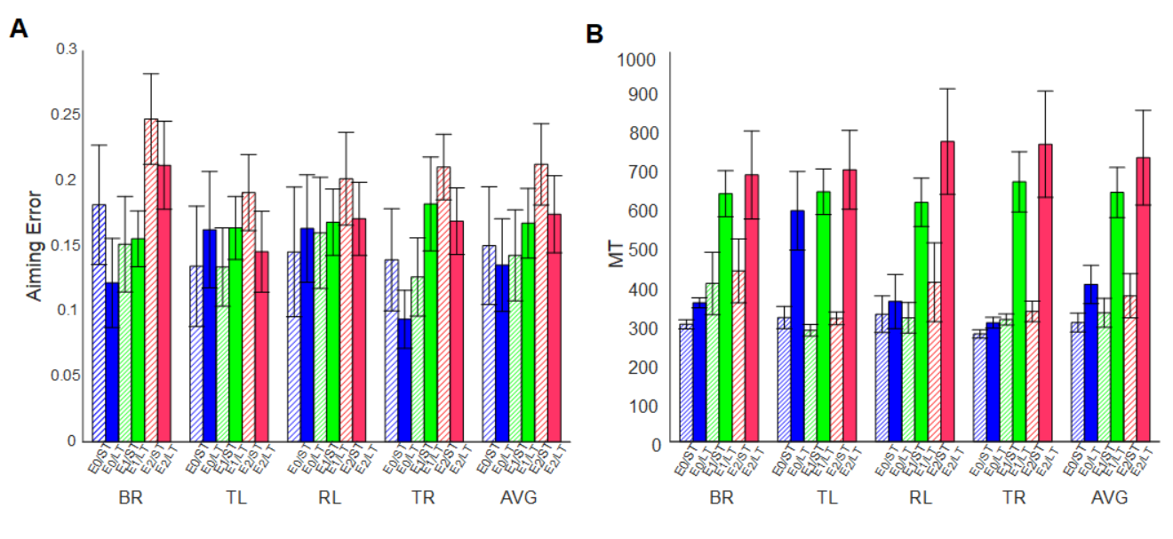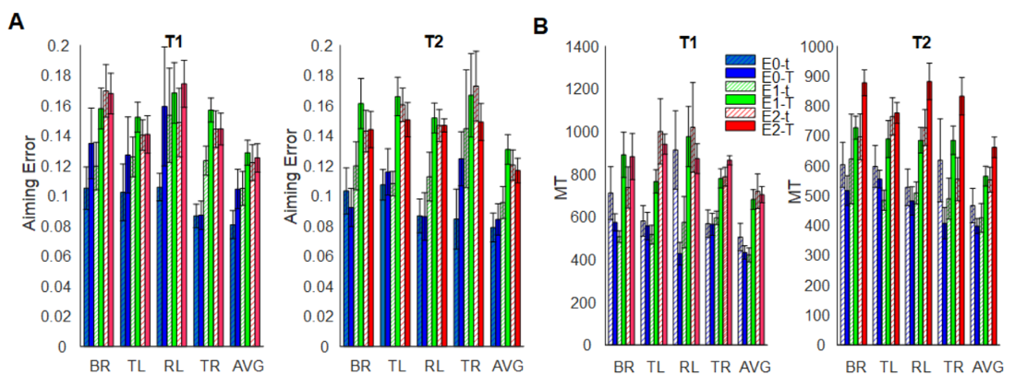

Bibliography
Berret B, Conessa A, Schweighofer N, Burdet E (2021) Stochastic optimal feedforward-feedback control determines timing and variability of arm movements with or without vision. PLOS Computational Biology 17:e1009047.
Bogacz R, Hu PT, Holmes PJ, Cohen JD (2010) Do humans produce the speed-accuracy trade-off that maximizes reward rate? Q J Exp Psychol (Colchester) 63:863–891.
Cos I, Bélanger N, Cisek P (2011) The influence of predicted arm biomechanics on decision making. Journal of Neurophysiology 105:3022–3033.
Cos I, Deco G, Gilson M (2021) The Influence of Intrinsic Motivation on Decisions Between Actions.
Cos I, Duque J, Cisek P (2014) Rapid prediction of biomechanical costs during action decisions. Journal of Neurophysiology 112:1256–1266.
Cos I, Medleg F, Cisek P (2012) The modulatory influence of end-point controllability on decisions between actions. J Neurophysiol 108:1764–1780.
Fitts PM (1954) The information capacity of the human motor system in controlling the amplitude of movement. 1954. J Exp Psychol Gen 121:262–269.
Gallivan JP, Chapman CS, Wolpert DM, Flanagan JR (2018) Decision-making in sensorimotor control. Nature Reviews Neuroscience 19:519–534.
Gibson JJ (1979) The Ecological Approach to Visual Perception. Boston: Houghton Mifflin.
Goble JA, Zhang Y, Shimansky Y, Sharma S, Dounskaia NV (2007) Directional Biases Reveal Utilization of Arm’s Biomechanical Properties for Optimization of Motor Behavior. J Neurophysiol 98:1240–1252.
Guigon E, Baraduc P, Desmurget M (2008) Optimality, stochasticity, and variability in motor behavior. J Comput Neurosci 24:57–68.
Harris CM, Wolpert DM (1998) Signal-dependent noise determines motor planning. Nature 394:780–784.
Kahneman D, Tversky A (1979) Prospect Theory: An Analysis of Decision under Risk. Econometrica 47:263–291.
Keramati M, Dezfouli A, Piray P (2011) Speed/Accuracy Trade-Off between the Habitual and the Goal-Directed Processes. PLoS Comput Biol 7:e1002055.
Krakauer JW, Mazzoni P (2011) Human sensorimotor learning: adaptation, skill, and beyond. Current Opinion in Neurobiology 21:636–644.
Landy MS, Trommershäuser J, Daw ND (2012) Dynamic Estimation of Task-Relevant Variance in Movement under Risk. J Neurosci 32:12702–12711.
Morel P, Ulbrich P, Gail A (2017) What makes a reach movement effortful? Physical effort discounting supports common minimization principles in decision making and motor control. PLOS Biology 15:e2001323.
Morrison DD, Riley JD, Zancanaro JF (1962) Multiple shooting method for two-point boundary value problems. Commun ACM 5:613–614.
Norbury A, Valton V, Rees G, Roiser JP, Husain M (2016) Shared Neural Mechanisms for the Evaluation of Intense Sensory Stimulation and Economic Reward, Dependent on Stimulation-Seeking Behavior. J Neurosci 36:10026–10038.
Peternel L, Sigaud O, Babič J (2017) Unifying Speed-Accuracy Trade-Off and Cost-Benefit Trade-Off in Human Reaching Movements. Front Hum Neurosci 11 Available at: https://www.frontiersin.org/articles/10.3389/fnhum.2017.00615/full [Accessed May 14, 2018].
Rigoux L, Guigon E (2012) A Model of Reward- and Effort-Based Optimal Decision Making and Motor Control. PLoS Comput Biol 8:e1002716.
Sabes PN, Jordan MI (1997) Obstacle Avoidance and a Perturbation Sensitivity Model for Motor Planning. J Neurosci 17:7119–7128.
Salinas E, Scerra VE, Hauser CK, Costello MG, Stanford TR (2014) Decoupling speed and accuracy in an urgent decision-making task reveals multiple contributions to their trade-off. Front Neurosci 8 Available at: https://www.ncbi.nlm.nih.gov/pmc/articles/PMC4005963/ [Accessed December 12, 2019].
Shadmehr R, Orban de Xivry JJ, Xu-Wilson M, Shih T-Y (2010) Temporal Discounting of Reward and the Cost of Time in Motor Control. J Neurosci 30:10507–10516.
Stevens JR, Rosati AG, Ross KR, Hauser MD (2005) Will Travel for Food: Spatial Discounting in Two New World Monkeys. Current Biology 15:1855–1860.
Summerside EM, Ahmed AA (2021) Using metabolic energy to quantify the subjective value of physical effort. Journal of The Royal Society Interface 18:20210387.
Todorov E (2004) Optimality principles in sensorimotor control. Nat Neurosci 7:907–915.
Todorov E, Jordan MI (2002) Optimal feedback control as a theory of motor coordination. Nat Neurosci 5:1226–1235.
Trommershäuser J, Maloney LT, Landy MS (2008) Decision making, movement planning and statistical decision theory. Trends in Cognitive Sciences 12:291–297.
Trommershäuser J, Mattis J, Maloney LT, Landy MS (2006) Limits to human movement planning with delayed and unpredictable onset of needed information. Exp Brain Res 175:276–284.
Wolpert DM, Landy MS (2012) Motor control is decision-making. Current Opinion in Neurobiology 22:996–1003.
Young SJ, Pratt J, Chau T (2009) Misperceiving the speed-accuracy tradeoff: imagined movements and perceptual decisions. Exp Brain Res 192:121–132.

